Model Report 2006

Accuracy : 0.6123

AUC Score (Test): 0.647983

citizen: 0.21257273852825165

pid3_leaner: 0.0751069113612175

age: 0.07482960820198059

approval_sen2: 0.06794687360525131

approval_gov: 0.06489045917987823

approval_rep: 0.06484929472208023

approval_sen1: 0.0625959113240242

approval_pres: 0.0593060739338398

ideo5: 0.05487258732318878

marstat: 0.053578104823827744

economy_retro: 0.043687816709280014

educ: 0.04354878142476082

race: 0.04338034987449646

employ: 0.04007380083203316

gender: 0.038760706782341

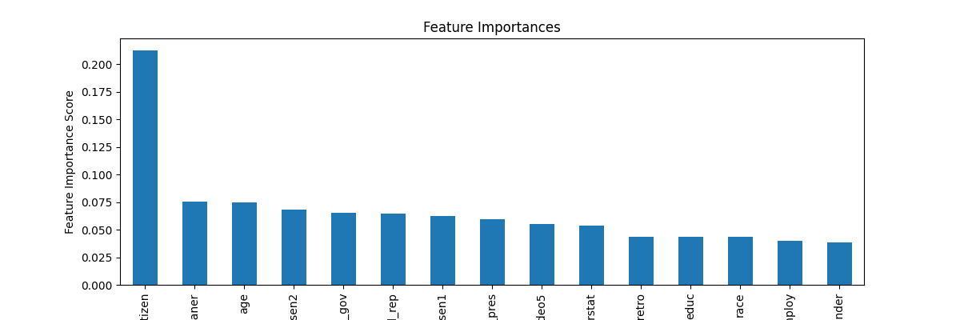

Model Report 2006 without citizenship

Accuracy : 0.61

AUC Score (Test): 0.643892

age: 0.0933489128947258

pid3_leaner: 0.09325776994228363

approval_sen2: 0.08794057369232178

approval_rep: 0.0827220007777214

approval_gov: 0.08086684346199036

approval_sen1: 0.07739926129579544

approval_pres: 0.07592009007930756

ideo5: 0.06901836395263672

marstat: 0.06859210878610611

race: 0.0577094666659832

economy_retro: 0.05688629671931267

educ: 0.05558639019727707

employ: 0.052590787410736084

gender: 0.04816112667322159

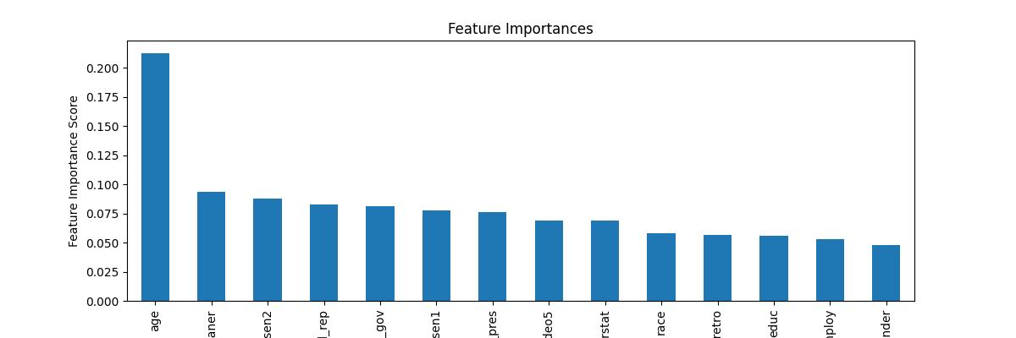

Model Report 2008

Accuracy : 0.7216

AUC Score (Test): 0.691408

citizen: 0.31890740990638733

pid3_leaner: 0.11289725452661514

ideo5: 0.09238716959953308

approval_rep: 0.05336543917655945

age: 0.04718391224741936

educ: 0.04195411130785942

marstat: 0.041259247809648514

approval_sen1: 0.038318924605846405

religion: 0.034187670797109604

race: 0.03369627147912979

approval_sen2: 0.033331550657749176

approval_pres: 0.03238411247730255

approval_gov: 0.03228439390659332

employ: 0.031575098633766174

gender: 0.030695315450429916

economy_retro: 0.02557213604450226

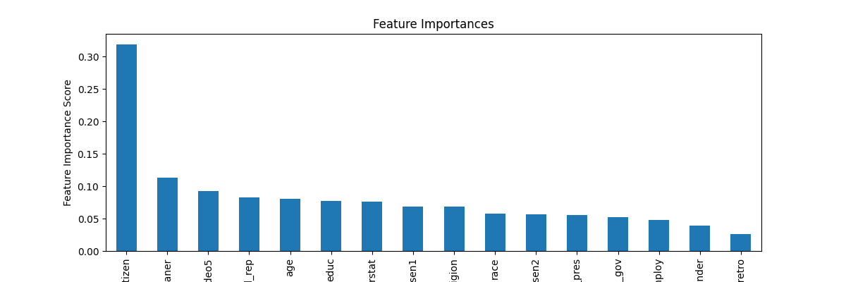

Model Report 2008 without citizenship

Accuracy : 0.7164

AUC Score (Test): 0.685128

pid3_leaner: 0.162329763174057

ideo5: 0.1297890543937683

approval_rep: 0.07582800835371017

age: 0.06993231922388077

educ: 0.06183597818017006

marstat: 0.05770473554730415

approval_sen1: 0.05635834485292435

race: 0.05287132412195206

religion: 0.05028640106320381

approval_sen2: 0.05003977194428444

approval_pres: 0.04944164305925369

approval_gov: 0.0488414391875267

gender: 0.04788609966635704

employ: 0.04746805503964424

economy_retro: 0.03938710689544678

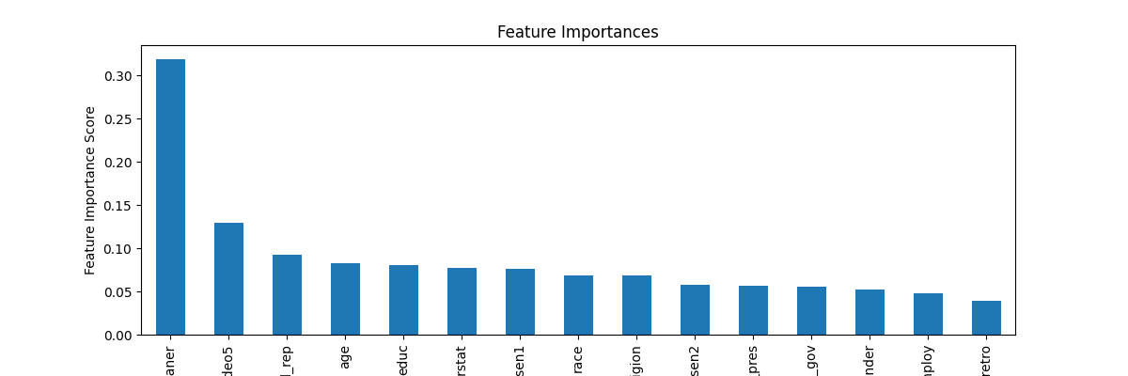

Model Report 2010

Accuracy : 0.735

AUC Score (Test): 0.766297

citizen: 0.16577664017677307

age: 0.12980563938617706

race: 0.08382192999124527

ideo5: 0.0707852691411972

approval_rep: 0.07006440311670303

approval_sen1: 0.06880709528923035

pid3_leaner: 0.06499825417995453

approval_pres: 0.0542696975171566

educ: 0.048732902854681015

gender: 0.04823260381817818

approval_sen2: 0.04613036289811134

marstat: 0.03612755611538887

approval_gov: 0.03190302476286888

employ: 0.03047260083258152

economy_retro: 0.02795889601111412

religion: 0.022113140672445297

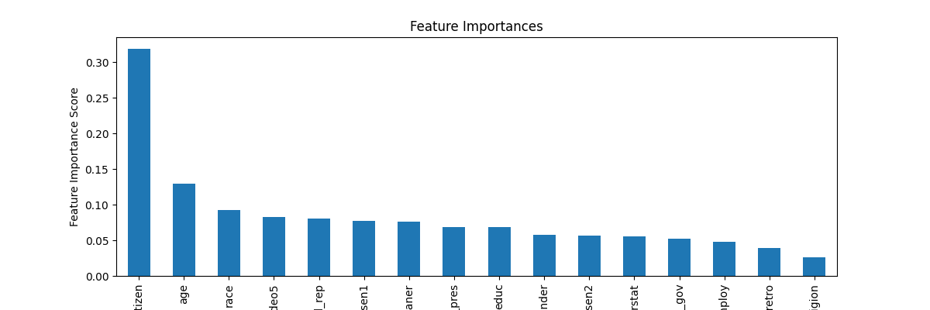

Model Report 2010 without citizenship

Accuracy : 0.7328

AUC Score (Test): 0.763936

age: 0.14766040444374084

race: 0.09774112701416016

approval_rep: 0.08786673098802567

pid3_leaner: 0.08417815715074539

ideo5: 0.08037129044532776

approval_sen1: 0.07954464852809906

approval_pres: 0.0685664564371109

gender: 0.05871514603495598

educ: 0.05801943317055702

approval_sen2: 0.05710732936859131

marstat: 0.04104447737336159

approval_gov: 0.039760854095220566

employ: 0.03756549209356308

economy_retro: 0.033828578889369965

religion: 0.028029929846525192

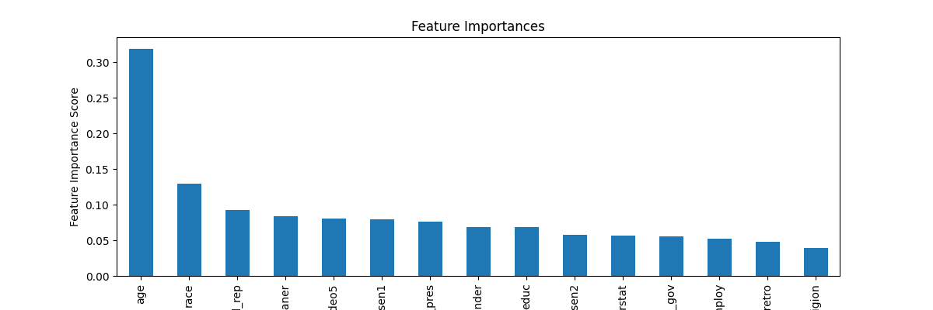

Model Report 2012

Accuracy : 0.7207

AUC Score (Test): 0.728259

citizen: 0.30964580178260803

pid3_leaner: 0.12140798568725586

age: 0.08996620029211044

educ: 0.060763973742723465

race: 0.051337067037820816

approval_rep: 0.05116559937596321

ideo5: 0.04612795636057854

approval_pres: 0.0431009940803051

economy_retro: 0.038734033703804016

approval_sen2: 0.036923397332429886

marstat: 0.03417637199163437

approval_sen1: 0.030698012560606003

religion: 0.0230878833681345

employ: 0.022020243108272552

approval_gov: 0.020895110443234444

gender: 0.019949404522776604

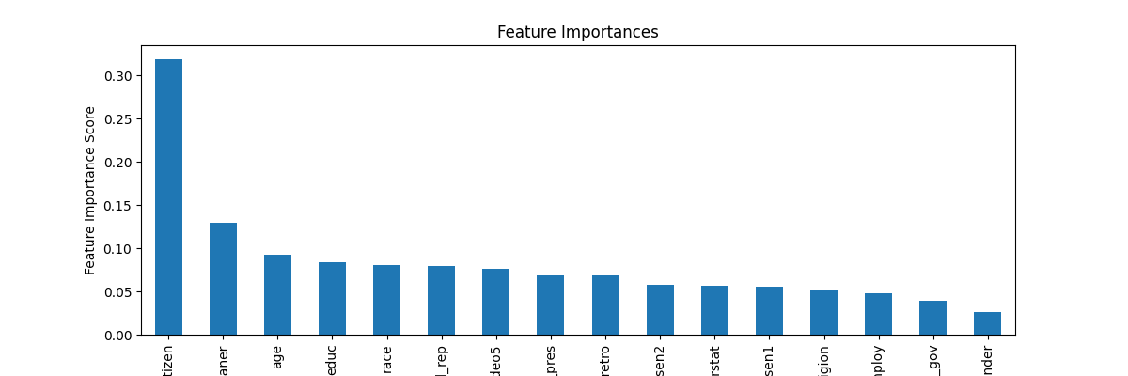

Model Report 2012 without citizenship

Accuracy : 0.7188

AUC Score (Test): 0.723663

pid3_leaner: 0.17527373135089874

age: 0.12478603422641754

educ: 0.08628053218126297

race: 0.08108919858932495

approval_rep: 0.0739869698882103

ideo5: 0.06995048373937607

approval_pres: 0.05925721675157547

economy_retro: 0.05476997792720795

approval_sen2: 0.053691666573286057

approval_sen1: 0.046005237847566605

marstat: 0.045941513031721115

religion: 0.034897949546575546

employ: 0.0331750325858593

gender: 0.030451955273747444

approval_gov: 0.03044244460761547

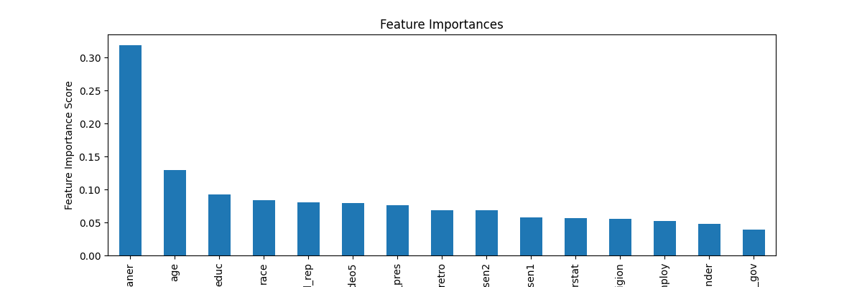

Model Report 2014

Accuracy : 0.721

AUC Score (Test): 0.803585

vv_party_prm: 0.6452382206916809

citizen: 0.05477866530418396

educ: 0.047154154628515244

age: 0.04483962431550026

race: 0.0338011234998703

pid3_leaner: 0.02680092863738537

approval_sen2: 0.019312551245093346

ideo5: 0.017151622101664543

employ: 0.01554916612803936

approval_sen1: 0.015412680804729462

approval_rep: 0.013543066568672657

economy_retro: 0.013206102885305882

marstat: 0.011589759029448032

approval_pres: 0.011510650627315044

gender: 0.010367585346102715

approval_gov: 0.01001767348498106

religion: 0.009726536460220814

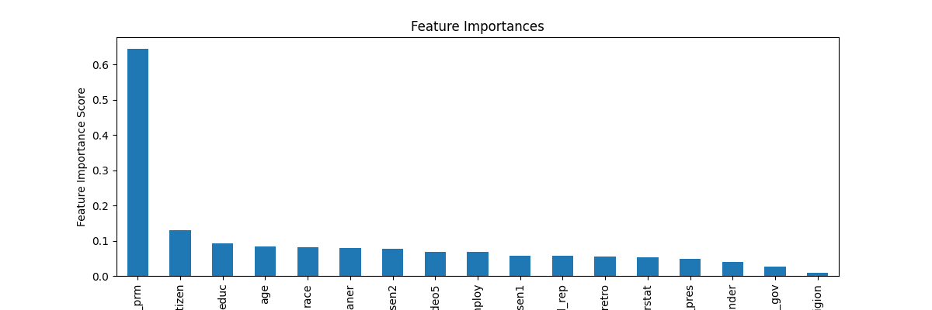

Model Report 2014 without citizenship

Accuracy : 0.7174

AUC Score (Test): 0.801575

vv_party_prm: 0.6706665754318237

educ: 0.05109407752752304

age: 0.04996400326490402

race: 0.03642489016056061

pid3_leaner: 0.029986124485731125

approval_sen2: 0.020168527960777283

ideo5: 0.01792851649224758

approval_sen1: 0.016483331099152565

employ: 0.015470263548195362

approval_rep: 0.015449268743395805

economy_retro: 0.015064805746078491

approval_pres: 0.013937855139374733

marstat: 0.01375968661159277

gender: 0.011597427539527416

approval_gov: 0.011298596858978271

religion: 0.010706094093620777

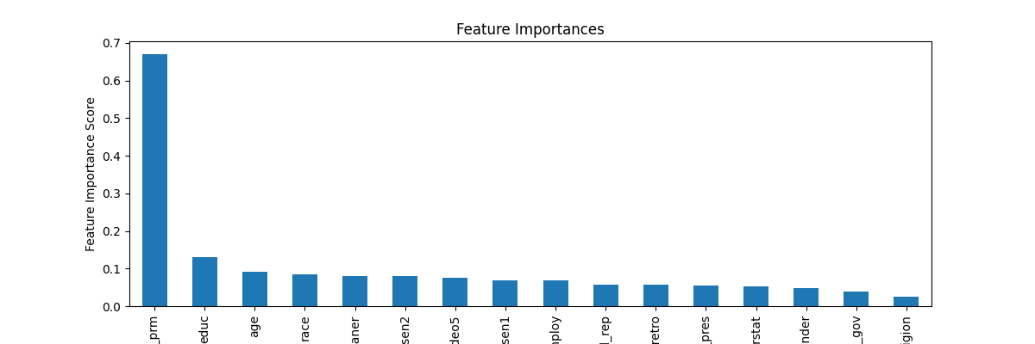

Model Report 2016

Accuracy : 0.6985

AUC Score (Test): 0.757345

vv_party_prm: 0.36468490958213806

citizen: 0.2002025544643402

pid3_leaner: 0.06849245727062225

age: 0.06304874271154404

ideo5: 0.0377148874104023

race: 0.03052305243909359

educ: 0.029723601415753365

approval_rep: 0.025764862075448036

approval_pres: 0.023964768275618553

economy_retro: 0.023464573547244072

approval_gov: 0.02299427054822445

approval_sen1: 0.021068241447210312

approval_sen2: 0.019197138026356697

employ: 0.01832570880651474

religion: 0.017177443951368332

gender: 0.017111392691731453

marstat: 0.016541332006454468

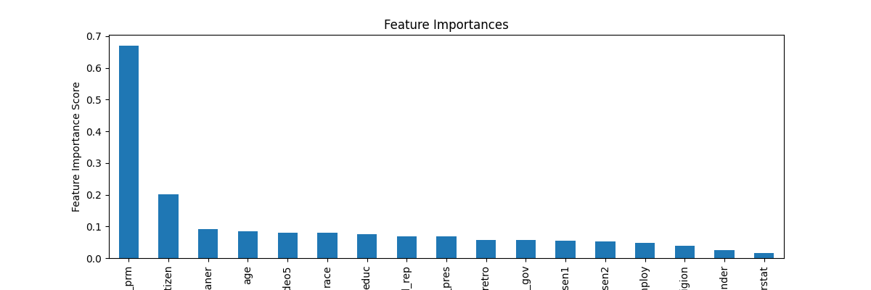

Model Report 2016 without citizenship

Accuracy : 0.695

AUC Score (Test): 0.751981

vv_party_prm: 0.4624425768852234

pid3_leaner: 0.08148490637540817

age: 0.07626611739397049

ideo5: 0.0446137860417366

race: 0.04245249554514885

educ: 0.03679448738694191

approval_rep: 0.03338725119829178

approval_gov: 0.02837366983294487

approval_pres: 0.027964912354946136

economy_retro: 0.02792993187904358

approval_sen1: 0.026349881663918495

approval_sen2: 0.024011235684156418

religion: 0.022752253338694572

gender: 0.02232528291642666

employ: 0.02188185229897499

marstat: 0.02096935734152794

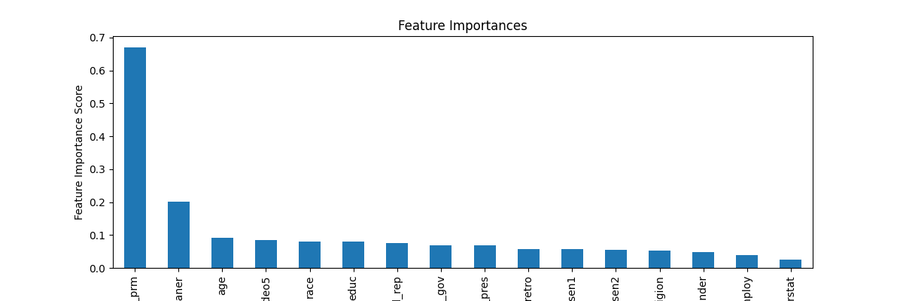

Model Report 2018

Accuracy : 0.7359

AUC Score (Test): 0.798130

vv_party_prm: 0.6246408224105835

citizen: 0.0879625529050827

age: 0.03434516489505768

pid3_leaner: 0.031180115416646004

approval_pres: 0.026904398575425148

educ: 0.026381313800811768

ideo5: 0.024813054129481316

race: 0.02427067793905735

approval_sen1: 0.019532131031155586

economy_retro: 0.01669275388121605

approval_sen2: 0.016545338556170464

marstat: 0.015258455649018288

employ: 0.011108235456049442

religion: 0.011044741608202457

approval_gov: 0.010870073921978474

approval_rep: 0.010863264091312885

gender: 0.0075868587009608746

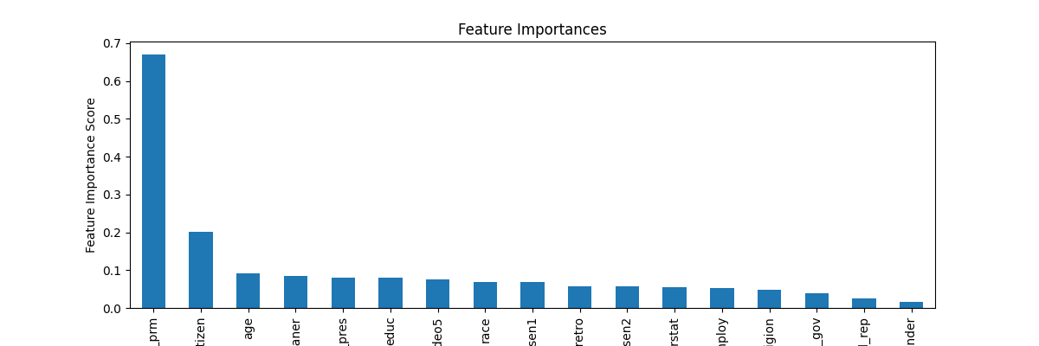

Model Report 2018 without citizenship

Accuracy : 0.7317

AUC Score (Test): 0.794097

vv_party_prm: 0.691342294216156

age: 0.036794260144233704

pid3_leaner: 0.0326540544629097

approval_pres: 0.02886246144771576

educ: 0.02804749831557274

race: 0.026359207928180695

ideo5: 0.025746863335371017

approval_sen1: 0.020510897040367126

economy_retro: 0.018330413848161697

approval_sen2: 0.017832204699516296

marstat: 0.015879472717642784

employ: 0.012403962202370167

religion: 0.012293839827179909

approval_rep: 0.012251581065356731

approval_gov: 0.012176536954939365

gender: 0.00851449090987444

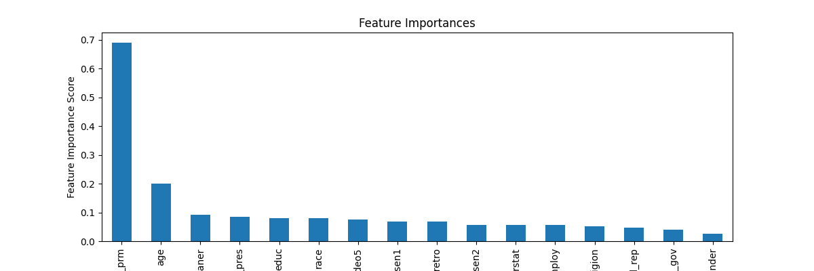

Model Report 2012-2018's elections with registered party

Accuracy : 0.719

AUC Score (Test): 0.784828

vv_party_prm: 0.7329386472702026

pid3_leaner: 0.03736766800284386

age: 0.03453528508543968

year: 0.023768553510308266

educ: 0.02365042082965374

race: 0.02310352213680744

ideo5: 0.0185829009860754

approval_pres: 0.01371373888105154

approval_sen2: 0.01194441132247448

approval_sen1: 0.011518441140651703

approval_rep: 0.011159123852849007

economy_retro: 0.010991786606609821

marstat: 0.009851773269474506

employ: 0.009658858180046082

religion: 0.009296152740716934

approval_gov: 0.00911270547658205

gender: 0.008806005120277405

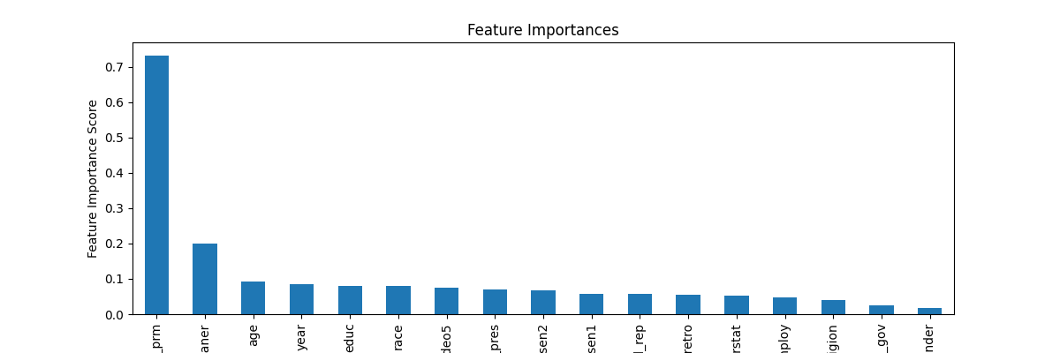

Model Report 2012-2018's elections without registered party

Accuracy : 0.7079

AUC Score (Test): 0.750234

age: 0.14384272694587708

pid3_leaner: 0.14199194312095642

educ: 0.09502214938402176

year: 0.0828780084848404

race: 0.07895310968160629

ideo5: 0.06807182729244232

approval_pres: 0.053277794271707535

approval_rep: 0.0451970174908638

approval_sen2: 0.04207565635442734

economy_retro: 0.04180784523487091

approval_sen1: 0.04014329984784126

marstat: 0.03643183037638664

employ: 0.03593309968709946

religion: 0.03318330645561218

approval_gov: 0.03145010024309158

gender: 0.02974027208983898

